# Nonholonomic Mobile Robot

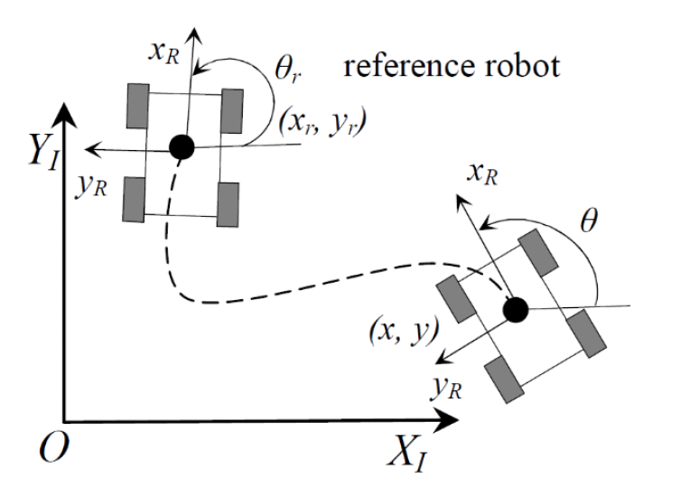

Figure 1. Schematic of the nonholonomic mobile robot

A mobile robot that is subject to nonholonomic restrictions is referred to as nonholonomic. Nonholonomic restrictions are limitations on the robot's speed; they do not condense the space of possible configurations.

Nonholonomic constraints can be exemplified by:

1. A car cannot veer off the road while it is moving forward.
2. A unicycle is completely immobile in the side.
3. A robot with differential drive cannot immediately rotate.

Robots that are subject to nonholonomic constraints, known as nonholonomic mobile robots, are harder to control than holonomic mobile robots. This is because the robot's mobility may be constrained by nonholonomic constraints.

**Proposed Control Schemes:**

1. MPC
2. LQR

# Project

1. System Modeling:
   * Develop a mathematical model of the system using first principles.
2. Controller Design:
   * Choose a control strategy from the proposed schemes
   * Design the controller gains based on the system model and desired performance criteria, such as stability and response time.
3. Software implementation:
   * Use MATLAB to simulate the system and to implement the control algorithm in simulation.
4. Documentation and Presentation:
   * Document your work in a report summarizing the project, including the system modelling, controller design, and results analysis.
   * Make a presentation to discuss the project and present the results to the class.